**TYPES OF SHOOTING SYSTEMS**

1. **SPRING MECHANISM**

The first category contains systems based on mechanical stored energy in a spring. This system is a very simple mechanism. A spring is wound up, held, and released at certain moment of time. It is applied in various configurations. Varying from basic spring systems to crossbow based mechanisms. Figure 1 contains a simplified model of a standard spring mechanism.

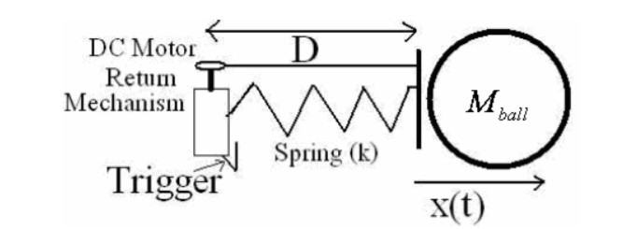

Figure 1 : Schematic model of a spring-based shooting mechanism

For this simple model the equation of motion holds.

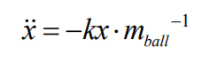

With Initial Values:

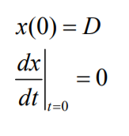

This system is very powerful, because much energy can be stored in a spring. The number of shots is almost unlimited, because it works on battery power. However the system has also several disadvantages: It takes a lot of space, weights several kg and it takes about time to reload. It is also very hard to control the shooting power. There are 2 ways to obtain variable shooting power, by varying the spring’s displacement or by taking energy away with a variable damper. These are difficult solutions and is rather impossible to achieve variable shooting power “on demand” without any time lag.

1. **PNEUMATIC SYSTEMS**

There are also shooting mechanisms which are based on pneumatic pressure. This is also a very basic technology. A large gas tank is placed somewhere in the robot and is brought on pressure before a match. At the front are one or more pneumatic cylinders connected with tubes to the air tank. In the tube(s) are solenoid valve’s which can operate as a “switch” or they can be controlled so they can regulate the airflow and shooting power. Shooting force depends on the pressure in the gas tank. High pressure is needed for a decent shooting force end thus a strong and heavy tank is needed. The number of shots depends on the size of the gas tank.

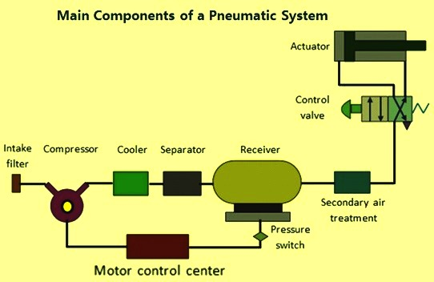

Figure 2: Schematic model of a pneumatic-based shooting mechanism

1. **SOLENOIDS**

The third principle used for shooting devices is self-inductance. By sending a current trough a turn of wire a magnetic field can be build. As the number of turns or current increases, the magnetic field increases too. With magnetism ferromagnetic materials can be attracted or repulsed.

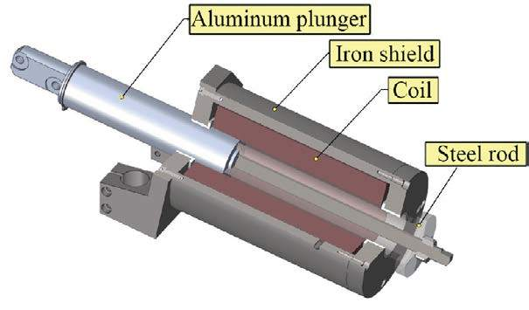

Figure3: Schematic model of a solenoid-based shooting mechanism

Advantages:

* It is able to shoot very fast
* It is rather small and lightweight
* Only a transformer, a capacitor, some resistors and a switch is used so it is in theory very reliable
* Shooting power can be varied by varying the time of the applied current

Disadvantages:

* The use of a solenoid is that it operates at a high voltage and current, so it can be quite dangerous.
* It uses a lot of power for a really short time
* Due to internal resistance, heat is generated when activated